OUTPUT:
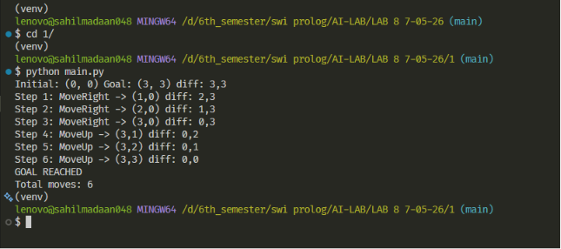

Lab 8
Program 1 —Robot Traversal Using Means-End Analysis
-
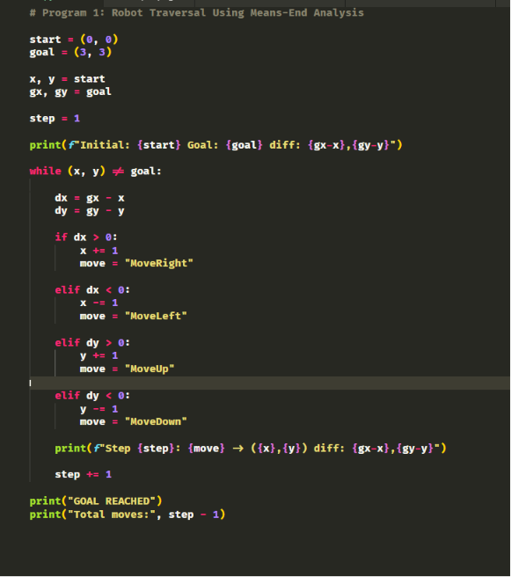

OUTPUT:

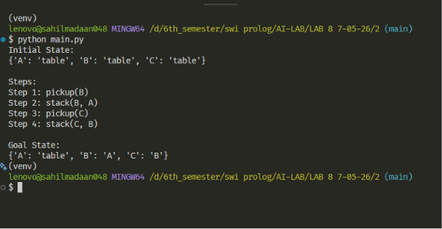

Lab 8
Program 2 —Block-World Using Means-End Analysis
-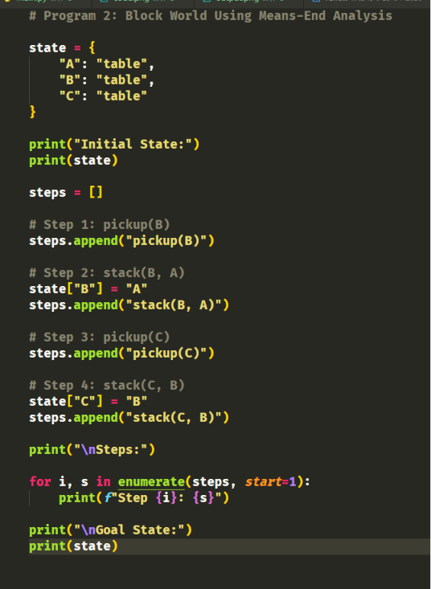

OUTPUT:

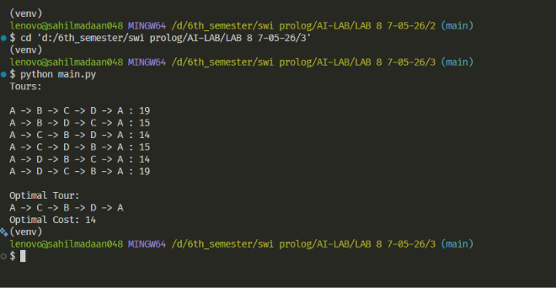

Lab 8
Program 3 — Travelling Salesman Problem Using Brute Force
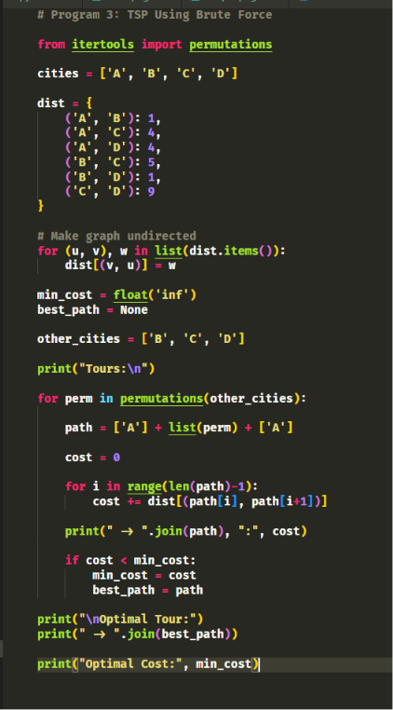

OUTPUT:

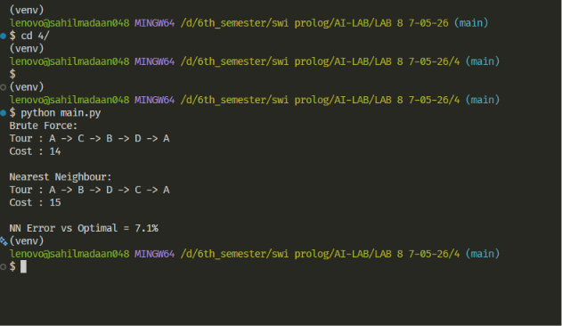

Lab 8
Program 4 — TSP: Brute Force vs Nearest Neighbour
